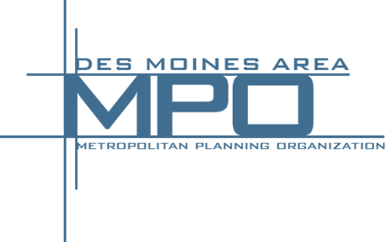
Polk County TAG
August 24, 2016
420 Watson Powell Jr. Way
Des Moines, IA
Suite 200 (Mead Conference Room)

“To bring human service agencies and transportation providers together for the common objective of improving mobility options for individuals in need.”

Agenda:

- Introductions
- Mobility Managers Update
  - Alison Walding
    - Transportation Resource Guide
  - Sarah Constable
    - HIRTA/DART project
- MPO Update
  - Mike Armstrong
- United Way OpportUnity Update
  - Helene Grossman
- Goodwill Update
  - Justin Bogers & Kevin Lord
- Mobility Matters Conference Update
  - September 29, 2016 at Goodwill Industries of Central Iowa
- Wrap Up/Final Discussion

Next Meeting: October 26, 2016 1-2:30 PM

