Cedar Rapids City Clerk’s Office
Mobile Food Vendor License
Administrative Rules
SOP #LIC-014  SOP Subject: Mobile Food Vendor License | Date: 2/28/2017

PURPOSE:
To outline the administrative rules authorized by Chapter 42A, Section 42A.04(C) and the process used to license a Mobile Food Vendor (Food Cart, Food Stand or Food Truck). Chapter 42A does not regulate door-to-door food sales (i.e. Schwans, Girl Scout cookies).
Food Cart – means a non-self-propelled vehicle food establishment which facilitates the preparation, marketing, and sale of food that is whole and unprocessed, prepared, packaged, and/or non-potentially hazardous or commissary-wrapped foods maintained at proper temperatures or precooked foods that require limited assembly, such as frankfurters.

Food Stand – means any article, device, fixture or equipment that is used as a place to provide food and includes, but is not limited to, food tents, food shacks, food pods or food booths that are non-motorized, with or without a mobile kitchen, and facilitates the preparation, marketing, and sale of food that is whole unprocessed, prepared and/or not potentially hazardous. Food stands are not lawfully permitted as a permanent structure.

Food Truck – means a self-propelled, or non-self-propelled vehicle or trailer, which is operable and is currently licensed through a North American Department of Motor Vehicles. A food truck contains a mobile kitchen and facilitates the preparation, marketing, and sale of food that is whole unprocessed, packaged, prepared and/or not potentially hazardous.

Anyone inquiring about a Mobile Food Vendor License should contact the Linn County Health Department (319-892-6000) to verify that their unit/stand meets all State requirements.
Parking requirements prior to 10 PM:
- Parking in a Numbered Parking Space (a license is needed from the City Clerk’s Office specifically for the numbered parking space) - the numbered parking space must be placarded by ParkCR to reserve the parking spot for the appropriate period of time (can’t pay at the parking kiosk, must be placarded by ParkCR). See Step # 1h for more details.

- Parking in a Metered Parking Space – (a license is needed but not specific approval for that parking space) – vendors can pay the fee at the meter for the appropriate period of time or they can pay ParkCR to placard the metered space in order to reserve the space. If it is after 6 pm or on a weekend ParkCr does not charge for parking, but if the vendor would like the spot reserved on weekdays after 6 pm or anytime on a weekend then they can contact ParkCR to placard.

Parking requirements after 10 PM until 2 AM:
- Vendor may legally park in any space Downtown – no placarding or hooding allowed. ParkCR currently does not charge parking fees after 6 pm (nor on weekends) so no parking charge if vending after 10 pm.

Exemptions (must still follow all applicable county, state and federal laws) –
- Mobile food vendors operating at an event that holds a Special Event Permit, a Carnival and Fair Operational Permit (or similar Fire Permit) or who are operating under a contract with the Parks Department
- Event only venues/areas – McGrath Amphitheatre, Hawkeye Downs, NewBo City Market
- Non-Profit Organizations (such sales must not be in excess of three consecutive days in any seven-day period at the same location)
- Farm Stands/Seasonal sale of unprocessed whole foods (parcel on which sale occurs must be classified as exempt, industrial or commercial)
- Mobile food vending is ancillary (secondary) to an existing primary use if all of the following are met:
- There is a primary land use in a building (cannot use a bare lot);
- Sale of food associated with the primary use of the building is legally allowed;
- Property is classified by the City Assessor as exempt, industrial or commercial;
- The mobile food vendor must own the property or a business on the property.
- Catering in which the food is prepared off-site and delivered (food is not prepared or served from a mobile food vending unit/stand)*
- Parties inquiring about selling candy from their home (including their porch) do not fall under Chapter 42A but should be referred to the Zoning department who handles home occupations
* Catering from a licensed Food Truck in which the food is prepared on and/or served from the mobile vending unit is allowed, however if in the Downtown area it will be necessary to request a temporary transfer of the mobile food vending license in order to move to a temporary location. Vendors would still need to be located 100 feet from a restaurant and have approval from Park CR to use a different space temporarily. A $50 transfer fee will apply (see the transfer procedure below for more details).
* Catering from a non-licensed Food Truck in which the food is prepared on and/or served from the mobile vending unit is not allowed.
Notes
Lemonade stands (residential) are not necessarily exempt from Chapter 42A. My recommendation if someone were to inquire about this type of sale is to suggest that instead of selling lemonade/treats, to give them away and ask for free will donations. This would allow them to operate their stand without being subject to a Mobile Food Vendor License. I would also recommend that they contact the Linn County Public Health Department to determine if a food service permit is needed.
Energov Business License Module - Mobile Food Vendor license (Food Cart, Food Stand or Food Truck).
PROCEDURE – for license:
- Applicant provides:
  - A completed “Mobile Food Vendor License” application.
- Make sure the application is legible and complete.
- A completed application will need to be submitted for each unit/stand that is applying to be licensed.
- Refer to the “Mobile Food Vendor License Application Checklist” (attached below) if needed for additional items required.
  - A copy of the food service license issued to the applicant by the State of Iowa Department of Inspections & Appeals-Food and Consumer Safety Bureau (please see Linn County Public Health for questions).
- Applicants participating in temporary events may submit a copy of their Linn County Public Health Temporary Food Service application.
- If the unit’s home base is in a different Iowa county, the mobile food unit license issued by their home county health department is sufficient if the unit is returning to that home base each night.
  - A Certificate of Insurance with the City of Cedar Rapids listed as a Certificate Holder showing proof of General Liability Insurance, including products liability coverage, in the amount of $1,000,000 or more per occurrence and $1,000,000 for property damage and Automobile Liability Insurance (if applicable).
  - Color photographs of the mobile food vending unit/stand (new applicants only).
  - A copy of the mobile food vending unit’s motor vehicle registration (drivable vehicles only).
  - A copy of the mobile food vending unit’s Blue Zones Certification (if applicable).
  - If an LP permit is issued by the Cedar Rapids Fire Department, proof of payment for the LP permit will need to be provided to the City Clerk’s Office before the Mobile Food Vendor License will be released.
- If the applicant has not yet contacted the Fire Marshal’s office, ask them to do so – 319-286-5166.
- Vendors that do not use LP may still be subject to a Fire inspection to verify that the proper fire extinguishers are in place.
  - Food Trucks are allowed to have one (or two if the truck is too large for one space) numbered parking space in the Downtown area.
- If a numbered space is desired, timestamp a “Park Cedar Rapids Food Truck Parking Agreement” and have them follow up with Park CR to reserve a space.
  - Make sure that the applicant has a copy of the Mobile Food Vending handout that includes important information regarding the rules and regulations set by Chapter 42A of the Municipal Code and also a list of important contacts (Health Dept., Fire, Park CR, etc.).
  - As a general rule, I do not accept applications unless all documentation required is provided with the application.
  - All of the documents provided will need scanned and saved to your computer for later import into Energov.

- A DCI is not required for this license.

- Collect the license fee.
  - $100 (1 week), $300 (6 months), $550 (1 year) – per unit/stand.
- License fees can be refunded minus $50 (amount of the license fee that is non-refundable) if the mobile food vendor license is denied or if the application is withdrawn prior to issuance. No other refunds will be granted.
  - Blue Zones certified vendors will receive a $50 discount:
- $250 (6 months), $500 (1 year).
- Must submit a copy of their certification when applying.
  - Only cash or check (no starter checks) are accepted. Checks can be made out to the City Treasurer or the City of Cedar Rapids.
  - If paying by check, stamp the back of the check.
  - Note the check number (if applicable) on the application.

- Create the license in Energov.
- Click on the Energov “E” and search under Business License-License Viewer- Business (using the DBA field) for the business.
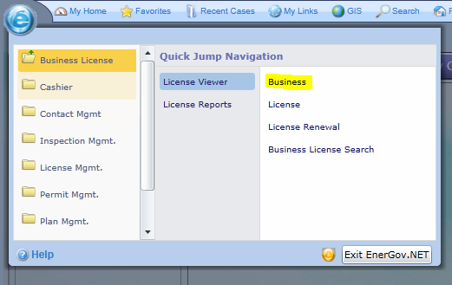
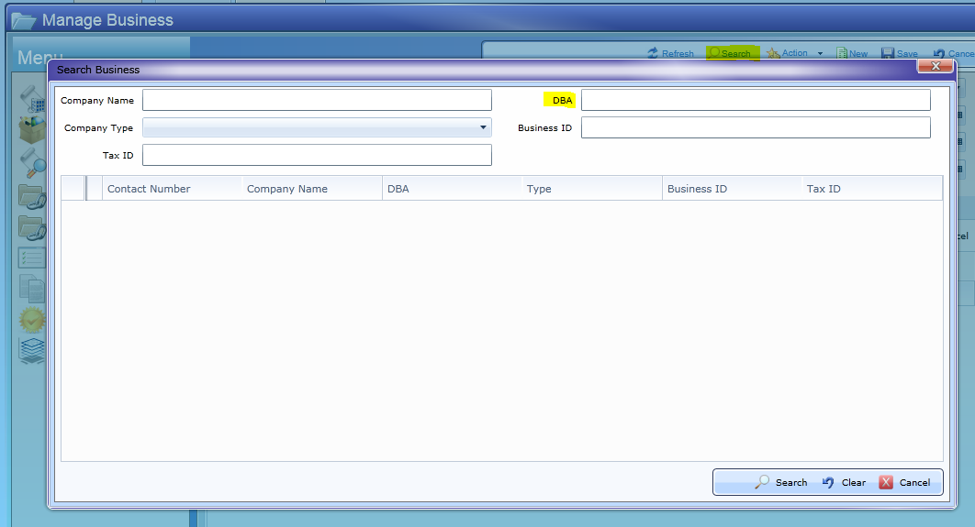

- If the business is not found, see Energov Instructions for adding a new business.
- Select the correct business.
- Select “Attached Licenses” from the menu on the left-hand side.
- Select the Mobile Food Vendor License that is due to expire.
- If the business has never had a Mobile Food Vendor license, create a new license using the “Action” tab at the top and then “Create License”.
- You will need to select the “License Type” (food cart, food stand or food truck) and the “Classification” (1 week, 6 months, 1 year).
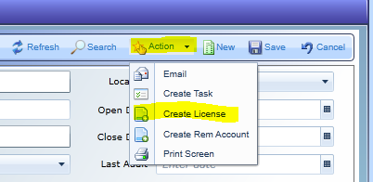
- If the business has a previous Mobile Food Vendor License, click “Action” at the top and then “Renew License”.
- Select “Calculate Fee”, “Renew” and then “OK”.
- Verify that all information is correct (addresses, contacts, etc.).
- Make any necessary changes and save the record.
- Write the Energov license number that generates after saving on the top of the application.

- Enter the payment into Energov.
  - Click on the “Fees” tab.
- The fees should automatically be there, if not choose “Add” to add the fees and then save the record.
- If the vendor has submitted proof of Blue Zones certification, select “Additional Info” on the left-hand side of the screen and check “Blue Zones”.
- This must be checked for the correct discounted fees to be associated with the license.
- Select “Pay Now” at the bottom of the screen.
- Enter the necessary payment information and save.
- Click on “Documents” on the left-hand side of the screen.
- Click on “Receipt” and then “Create Report”.
- Print the receipt that is generated.
- See SOP #LIC-036 for information on exporting the receipt and sending it electronically if the applicant does not have time to wait for the receipt.
- Close the receipt screen.
- Close the payment screen by clicking on the “X” on the Manage Payment tab.
  - On the License Details screen, click “Refresh” to see the changes to the fee status (should now display “Paid in full”).
  - Save the record.
  - Note the transaction number (found on the receipt) at the top of the application.
  - Give the printed receipt to the applicant.

- Inform the applicant that you will call them when the license is approved and ready for pickup.
- Licensing a Mobile Food Vendor can take 1-2 weeks.

- Enter parking space information in Energov.
  - If the applicant has indicated that they are applying to have a numbered parking space/spaces, Park Cedar Rapids will return a copy of their approved agreement with the vendor.
- Make sure to scan the Park CR agreement so that it can be attached to the license with the other documents scanned earlier in the process.
  - Click on “Additional Info” on the left-hand side of the screen.
- Enter parking space number/numbers (if applicable).
  - Return to “License Details” and enter a description of the approved location in the “Description” field.
  - Save the record.

- Attach supporting documentation to the Energov license.
- Click on “Documents” on the left-hand side of the screen.
- Select the “Attachments” tab.
- Attach the files that were scanned in earlier in the process (application, registration, photos, etc.) by using the “Add Attachment” button at the top of the page.
- Make sure to save the record after adding the attachments.

- Initiate the application/insurance reviews in Energov.
- Click on “Workflow Details” on the left-hand side of the screen.
- Right click on “Mobile Food Units Plan Review” and a plan case will be triggered.

- Enter the plan case information into Energov.
- Click on the “Contacts” tab.
- Select the appropriate contact type.
- Save the record.
- Click on “Documents” on the left-hand side of the screen.
- Click on the “Attachments” tab.
- Attach the same items that were attached earlier in the process to the license.
- Save the record.
- Write the plan case number at the top of the application.
- Click on “Workflow Details”.
- Right click on “Mobile Food Units Review” and select “Create”. This will trigger a notification for Fire.
- There will also be an item listed as “County Health”. This can be changed to “Approved” after you have received a copy of the applicant’s food service license. You can also use the drop-down menu to select your name as the contact for this item if it is not already listed.
- Right click on “Bond/Insurance” and select “Receive Submittal”.
- Save the record.
- When you receive notification back that all “Mobile Food Units Review” items have been approved, return to the plan case.
- The easiest way to return to the plan case is to enter the license in Energov (see item #11a below for additional information on returning to the license), select “Attached Records” from the menu on the left-hand side and then select the “Plan” tab. You should be able to select the plan case from here.
- Select the plan case’s “Workflow Details” tab and verify that all items are approved.
- If both “Mobile Food Units Review” and “Bond/Insurance” are approved (green), right click on “Review” and select approved. This will turn the “Review” green as well.
- If the “Workflow Details” status still shows “Under Review”, use the drop-down menu to change the status to “Completed”.
- Use the arrow in the menu on the top left-hand side to return to the “Plan Details”.
- Change the “Plan Status” from “Under Review” to “Approved”.
- Save the record.
- “X” out of the plan case.

- Create the Mobile Food Vendor License in Energov (after the plan case has been approved).
  - Return to the license (if you do not already have it open) by clicking on the Energov “E” and navigating to Business License-License Viewer-License and search using the Energov license number that is written on the application.
  - Click on “Workflow Details” on the left-hand side of the screen.
- If the “Mobile Food Units Review” is not green, use the “Refresh” button to show the changes.
- The “Mobile Food Units Review” should automatically change to approved (green) when the plan case is approved.
- Right click on “Review” and select “Approved”
- Save the record.
- Click on the arrow at the top left that will return you to the “License Details”.
  - Change the license status from “Under Review” to “Issued”.
  - Verify that the “Issued Date” and “Expiration Date” are correct.
- Save the record.
  - Click on “Documents” on the left-hand side of the screen.
- Click on “Business License” and then “Create Report”.
- Verify that all information on the license is correct.
- Print the license (color printer) and then “X” out of the license page.
  - Click on “Workflow Details” on the left-hand side of the screen.
- Right click on “Issue Bus. License” and select “Printed”.
- Right click on “Issuance” and select “Approved”.
- All items in the “Workflow Details” should now be green.
  - Make a copy of the license and attach it to the application for your records.

- Apply the City Seal to the license.

- Call the applicant to pick up the license.

PROCEDURE – for a temporary transfer:
- Applicant provides:
  - A completed “Food Truck Transfer” application.
- Application should be accompanied by an approved Food Truck Parking Agreement from Park CR.
  - Scan application and Park CR paperwork for later import into Energov.

- Collect the transfer fee.
  - $50 (temporary transfer - voluntary), $0 (temporary transfer - construction) – per truck.
  - Only cash or check (no starter checks) are accepted. Checks can be made out to the City Treasurer or the City of Cedar Rapids.
  - If paying by check, stamp the back of the check.
  - Note the check number (if applicable) on the application.

- Create the transfer license in Energov.
- Click on the Energov “E” and search under Business License-License Viewer- Business (using the DBA field) for the business.

- Select the correct business.
- Select “Attached Licenses” from the menu on the left-hand side.
- Using the “Action” tab at the top select “Create License”.
- You will need to select “Food Truck” as the “License Type” and “Temporary Transfer” as the “Classification”.
- Verify that all information is correct (addresses, contacts, etc.).
- Make any necessary changes and save the record.
- Write the Energov license number that generates after saving on the top of the application.

- Enter the payment into Energov.
  - Click on the “Fees” tab.
- The fees should automatically be there, if not choose “Add” to add the fee (if applicable) and then save the record.
- If the transfer is for construction, you may need to delete the fee.
    - Use the red “X” on the side to delete the fee. It will ask for a reason, select “Other” and enter “Transfer for construction”.
    - Save the record.
- Select “Pay Now” at the bottom of the screen.
- Enter the necessary payment information and save.
- Click on “Documents” on the left-hand side of the screen.
- Click on “Receipt” and then “Create Report”.
- Print the receipt that is generated.
- See SOP #LIC-036 for information on exporting the receipt and sending it electronically if the applicant does not have time to wait for the receipt.
- Close the receipt screen.
- Close the payment screen by clicking on the “X” on the Manage Payment tab.
  - On the License Details screen, click “Refresh” to see the changes to the fee status (should now display “Paid in full”).
  - Save the record.
  - Note the transaction number (found on the receipt) at the top of the application.
  - Give the printed receipt to the applicant.

- Inform the applicant that you will call them when the transfer license is approved and ready for pickup.
  - Processing a transfer application should only take a few days at most.

- Enter the parking space information in Energov.
  - Click on “Additional Info” on the left-hand side of the screen.
- Enter the temporary parking space number/numbers.
  - Return to “License Details” and enter a description of the approved temporary location in the “Description” field.
  - Save the record.

- Attach supporting documentation to the Energov license.
- Click on “Documents” on the left-hand side of the screen.
- Select the “Attachments” tab.
- Attach the files that were scanned in earlier in the process (application, Park CR paperwork, etc.) by using the “Add Attachment” button at the top of the page.
- Make sure to save the record after adding the attachments.

- Initiate the application review in Energov.
- Click on “Workflow Details” on the left-hand side of the screen.
- Right click on “Mobile Food Units Plan Review” and a plan case will be triggered.

- Enter the plan case information into Energov.
- More information for this part of the license to follow. Since I have not processed one yet, I do not know what departments have been added to the workflow. It should only be Park CR which can be approved if the appropriate paperwork is submitted with the application.

- Create the Temporary Food Truck Transfer License in Energov (after the plan case has been approved).
  - Return to the license (if you do not already have it open) by clicking on the Energov “E” and navigating to Business License-License Viewer-License and search using the Energov license number that is written on the application.
  - Click on “Workflow Details” on the left-hand side of the screen.
- If the “Mobile Food Units Review” is not green, use the “Refresh” button to show the changes.
- The “Mobile Food Units Review” should automatically change to approved (green) when the plan case is approved.
- Right click on “Review” and select “Approved”
- Save the record.
- Click on the arrow at the top left that will return you to the “License Details”.
  - Change the license status from “Under Review” to “Issued”.
  - Verify that the “Issued Date” and “Expiration Date” are correct based on the application and Park CR paperwork.
- Save the record.
  - Click on “Documents” on the left-hand side of the screen.
- Click on “Business License” and then “Create Report”.
- Verify that all information on the license is correct.
- Print the license (color printer) and then “X” out of the license page.
  - Click on “Workflow Details” on the left-hand side of the screen.
- Right click on “Issue Bus. License” and select “Printed”.
- Right click on “Issuance” and select “Approved”.
- All items in the “Workflow Details” should now be green.
  - Make a copy of the license and attach it to the application for your records.

- Apply the City Seal to the license.

- Call the applicant to pick up the license.

PROCEDURE – for a permanent transfer or to add a parking space to an existing license:

- Applicant provides:
  - A completed “Food Truck Transfer” application.
- Application should be accompanied by an approved Food Truck Parking Agreement from Park CR.
  - Scan application and Park CR paperwork for later import into Energov.

- Collect the transfer fee.
  - $50 (permanent transfer from one approved parking space to another) or $5 (duplicate fee - if adding an approved parking space to an existing license that did not apply for a parking space initially) – per truck.
  - Only cash or check (no starter checks) are accepted. Checks can be made out to the City Treasurer or the City of Cedar Rapids.
  - If paying by check, stamp the back of the check.
  - Note the check number (if applicable) on the application.

- Return to the license in Energov.
  - Click on the Energov “E” and search under Business License-License Viewer- Business (using the DBA field) for the business.
  - Select the correct business.
  - Select “Attached Licenses” from the menu on the left-hand side.
  - Select the current Mobile Food Vendor License.
  - Note the license number on the transfer application.

- Enter the payment into Energov.
  - Click on the “Fees” tab.
- Choose “Add” to add the duplicate ($5) or transfer ($50) fee and then save the record.
- Select “Pay Now” at the bottom of the screen.
- Enter the necessary payment information and save.
- Click on “Documents” on the left-hand side of the screen.
- Click on “Receipt” and then “Create Report”.
- Print the receipt that is generated.
- See SOP #LIC-036 for information on exporting the receipt and sending it electronically if the applicant does not have time to wait for the receipt.
- Close the receipt screen.
- Close the payment screen by clicking on the “X” on the Manage Payment tab.
  - On the License Details screen, click “Refresh” to see the changes to the fee status (should now display “Paid in full”).
  - Save the record.
  - Note the transaction number (found on the receipt) at the top of the application.
  - Give the printed receipt to the applicant.

- Enter the parking space information in Energov.
  - Click on “Additional Info” on the left-hand side of the screen.
- Enter the new parking space number/numbers.
  - Return to “License Details” and replace the old description (if applicable) with a new description of the approved location in the “Description” field.
  - Save the record.

- Enter notes regarding the parking space addition or change.
  - Click on the “Notes” tab.
  - Select “Add Note”.
  - Note any information that would be helpful for future reference regarding the parking space addition or change.
  - Save the record.

- Attach supporting documentation to the Energov license.
  - Click on “Documents” on the left-hand side of the screen.
  - Select the “Attachments” tab.
  - Attach the files that were scanned in earlier in the process (application, Park CR paperwork, etc.) by using the “Add Attachment” button at the top of the page.
  - Make sure to save the record after adding the attachments.

- Print an updated Mobile Food Vendor License (only if you have received the approved Park CR Food Truck Placard Agreement).
  - Click on “Documents” on the left-hand side of the screen.
- Click on “Business License” and then “Create Report”.
- Verify that all information on the license is correct.
- The effective dates of the license will not change.
- The only changes should be the parking space number and the amount paid for the license.
- Print the license (color printer) and then “X” out of the license page.
  - Make a copy of the license and attach it to the application for your records.

- Apply the City Seal to the license.

- If the applicant did not wait for their license to be processed, call the applicant to pick up the license.

REFERENCES:
SOP #LIC-036 – Exporting an Energov Receipt
Mobile Food Vendor Application, Checklist and Transfer Application (see below)
Mobile Food Vending Handout - ..\..\..\Licensing\Applications\mfv-handout.pdf
Park CR Food Truck Placard Agreement -..\..\..\Licensing\Applications\Park CR Food Truck Meter Placard Agreement 2016.pdf

